R2C AI SOLUTION
Architecture Review Board (ARB) Document

Version | 1.0 | Date | 30 March 2026
Status | Draft – Pending ARB Review | Owner | R2C Engineering & Product Team
Stakeholder | ARB Panel | Program | Walden University – R2C Prototype

1. Business Requirements

The following requirements served as the guiding principles for the R2C AI solution design. All architectural decisions documented in this paper have been validated against these requirements.

1.1 Scope
In Scope | Out of Scope
- AI-generated student readiness summaries for Enrollment Specialists (ES)  - Personalized outbound communications (email, SMS) with Human-in-the-Loop (HITL) review  - Real-time risk scoring: readiness risk and engagement risk  - Census Success Plan per reserved student, continuously updated  - Integration with Salesforce, Banner, Canvas, and Omnichannel systems  - BigQuery as analytics/data warehouse layer  - Firestore as the real-time operational data layer  - Cloud Run as the agent execution environment | - Agents proactively contacting students on behalf of ES without HITL approval  - Qualtrics data integration  - Admin self-service dashboard for census/reserve definition  - Wally enhancements

1.2 Key Business Requirements
# | Requirement | Description
BR-01 | Real-time ES Experience | Enrollment Specialists must receive AI-generated insights and recommended actions with sub-second response times when viewing a student record in Salesforce.
BR-02 | Readiness Risk Monitoring | The system must continuously evaluate each reserved student against the R2C checklist (portal login, FAFSA, course registration, WWOW, contingencies, LMS login, class participation) and classify them as Low / Medium / High risk.
BR-03 | Engagement Risk Monitoring | The system must track periods of inactivity since Reserve and classify engagement risk based on activity gap thresholds relative to program start date.
BR-04 | Personalized Communications | Outbound emails and SMS must be hyper-personalized using student long-term memory, institution-specific policies, and current Census Success Plan state. All communications require HITL approval before sending.
BR-05 | Future-Looking Dataset | The data layer must support a future-looking dataset inclusive of future census dates, enabling proactive intervention ahead of the Day 10 milestone.
BR-06 | Full Audit & Traceability | All agent actions, communications drafted, and ES approvals must be logged for compliance and audit purposes.
BR-07 | Scalability | The solution must scale to support the full cohort of Walden reserved students without performance degradation.

2. R2C Use Case Overview

The R2C (Reserve to Census) AI solution supports Enrollment Specialists in moving reserved students to census by surfacing AI-generated summaries and recommended actions within Salesforce. The diagram below illustrates the end-to-end use case flow.

Layer | Capability | Detail
Trigger | Salesforce Student Opportunity Page | ES opens a reserved student record in Salesforce. This triggers the AI Summary interface.
AI Generated Summary Page | Rapid Analysis  - Quick narrative summary of recent contact and activities  - Clear visibility of student readiness status (e.g., logged in, FAFSA submitted)  - Engagement trends | Action-Oriented Support  - This week's priorities and actions to support goal-oriented outreach  - Resources to share with student  - Generate personalized email/SMS outreach  - Human in the Loop (HITL) for Send Email/SMS approval
ES Actions | - Send Email (via Eloqua)  - Send SMS (via Twilio)  - Talk over Phone (via CxOne) | All actions logged against the student record for traceability.
R2C AI Engine | - Achieve R2C goals for each student  - Continuously monitor Census Success Plan  - Draft communications personalized to student context  - Execute actions on behalf of ES (HITL required)  - Maintain student long-term memory  - Utilize institution vectorized data for policy adherence  - Capture whether call to action in communication was completed  - Visualization / journey map of census requirement completion | Powered by Vertex AI Agent Builder (ADK) on GCP. Agents operate on live student data from Firestore and are orchestrated by the Student Success Coordinator Agent.
Enterprise Systems | - Salesforce – CRM, task history, cases, IAR contingencies  - Banner – Student registration, program, term data  - Canvas – LMS login, orientation, assignment events  - Omnichannel: CxOne (phone), Eloqua (email), Twilio (SMS)  - BigQuery – Analytics and data warehouse

3. Solution Architecture

The architecture is designed around three core principles: real-time responsiveness, event-driven data synchronization, and agent-based AI orchestration. The diagram below illustrates the recommended end-to-end solution.

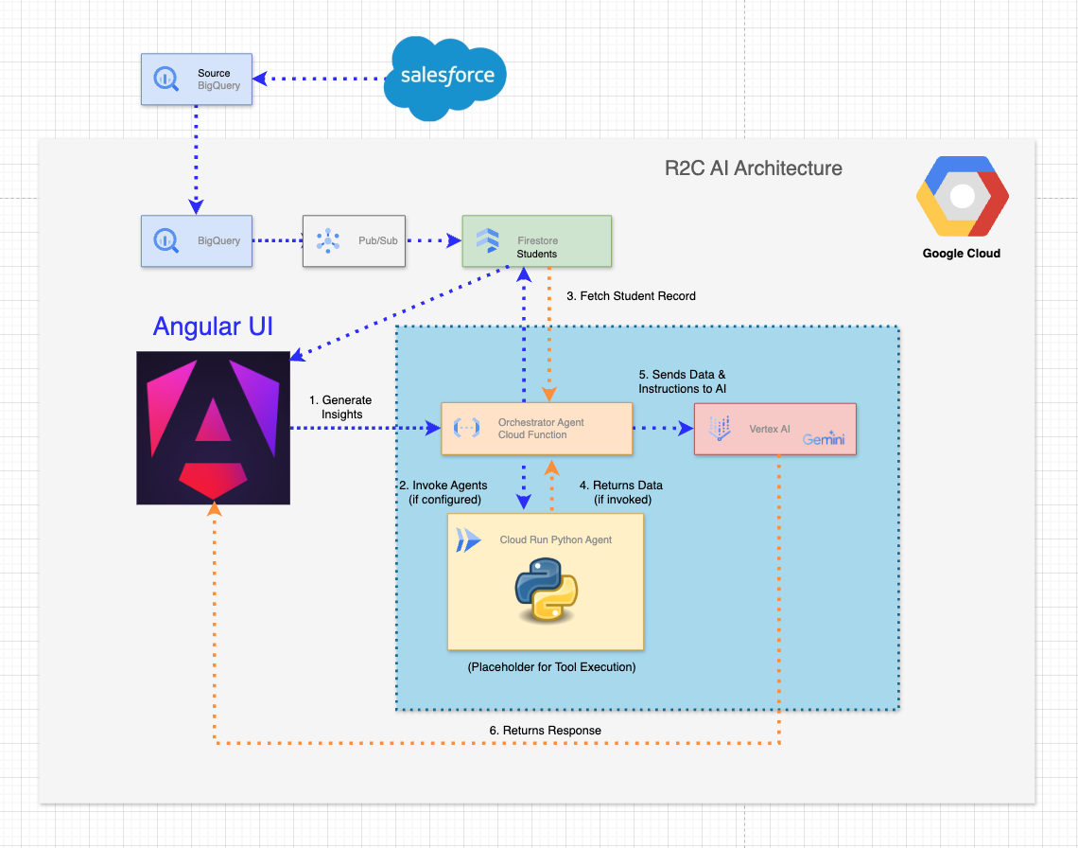
Figure 1: R2C AI Solution Architecture

3.1 Real-Time Application Flow
When an Enrollment Specialist clicks "Regenerate AI Insights" within Salesforce, the following sequence executes:

Step | Action
1 | The application reads the student record directly from Firestore (OLTP layer) - no warehouse query required.
2 | The AI logic (Census Success Plan Agent) evaluates the record, identifying: missing readiness checklist items, risk indicators (readiness and engagement), and engagement gaps.
3 | This structured payload is passed to Vertex AI (Gemini) via the Student Success Coordinator Agent running on Cloud Run.
4 | The Communication Generation Agent drafts personalized outputs: a recommended Next Best Action, a personalized email draft, and a personalized SMS message.
5 | The Angular UI (embedded in Salesforce via MuleSoft API/MCP) updates immediately with these results for ES review.
6 | If the ES approves, the communication is dispatched via the relevant Omnichannel channel (Eloqua / Twilio / CxOne).
7 | All actions are recorded in Cloud Logging and written back to the student record in Salesforce for full traceability.

4. Recommended Technology Stack

The solution is structured across three architectural planes: the Intelligence Plane (AI agents and models), the Experience Plane (user-facing interfaces and HITL tooling), and the Integration & Data Plane (system connectors and data stores).

4.1 Intelligence Plane
The Intelligence Plane houses the AI agent framework and foundation models. All agents are recommended to be built on Google ADK (Agent Development Kit) deployed on Vertex AI Agent Builder.

Agent / Capability | Description | Solution Options Evaluated | Recommendation
Student Success Coordinator Agent | Acts as the central orchestrator. Receives institution-defined R2C goals, decomposes them into sub-tasks, triggers the Census Success Plan Agent, Communication Generation Agent, and ES Interaction Agent. Maintains end-to-end workflow progress and HITL checkpoints. | - Vertex AI Agent Builder (ADK)  - Cloud Run – LangGraph  - CxOne / Eloqua / Twilio via MCP | Vertex AI Agent Builder (ADK)
Census Success Plan (R2C) Agent | Creates and maintains the Census Success Plan for each reserved student. Tracks milestones, updates risk flags, monitors behaviors, and triggers actions (via tools/MCP) based on live student data from Firestore. | Vertex AI Agent Builder (ADK) | Vertex AI Agent Builder (ADK)
Communication Generation Agent | Drafts hyper-personalized outreach for ES (nudge emails, SMS follow-ups, call agendas, post-call summaries) using student long-term memory, institution policies/knowledge, and current R2C plan state. Routes drafts for HITL review and logs artifacts back to student record. | Vertex AI Agent Builder (ADK) | Vertex AI Agent Builder (ADK)
Foundation Models | Provide access to large language models for content generation, reasoning, and structured output. | GCP Model Garden | GCP Model Garden (Gemini)

Rationale for ADK over LangGraph:
- GCP supports ADK natively; higher quality production support available on the platform
- ADK is Agent Builder's default framework — tighter ecosystem integration
- ADK features are functionally equivalent to LangGraph without the complexity of designing a state machine
- A previous PoC was completed using ADK, providing existing reference points
- LangGraph is already in use in TLO and remains a viable fallback if ADK PoC does not meet requirements

4.2 Experience Plane
The Experience Plane covers all user-facing interfaces, including the HITL approval flow, the AI summary surface in Salesforce, and administrative tooling for managing knowledge and communication templates.

Interface | Use Case Description | Options Evaluated | Recommendation
AI Summary Interface | Interface for ES presenting the AI-generated student summary and recommended actions. Embedded within the existing Salesforce Student Opportunity page. | Salesforce (native) | Salesforce via MuleSoft API / MCP
HITL Approval Interface | ES reviews, edits, and approves/rejects outbound email/SMS and Success Plan updates proposed by agents. Approvals are recorded against the student profile for traceability. | - Salesforce UI (preview in portal)  - Firebase | Custom UI on Cloud Run
Knowledge Management Interface | Allows ES teams to update R2C-relevant institutional FAQs, program policies, communication templates, Success Plan rules, and agent-facing reference material — without engineering involvement. Maintains governance, versioning, and auditability. | - Custom portal on Cloud Run with Vertex AI Search  - Firebase | Custom admin portal on Cloud Run
Self Service Interface | Enables admins to manage communication templates and tone guides, assign ES team roles, and review usage/quality metrics. | - Custom admin portal on Cloud Run  - Firebase | Custom admin portal on Cloud Run

5. Key Architectural Decision: Data Layer

5.1 Initial Approach
The initial architecture leveraged a Python-based agent using the BigQuery Toolset to query data directly from BigQuery, augment it with context from Salesforce, and pass the result into the AI layer.

While this approach was functionally viable, it introduced unacceptable latency:
- BigQuery queries added noticeable delay to each AI invocation
- The AI pipeline was dependent on warehouse response times
- End-to-end execution did not meet sub-second SLA expectations for the ES experience

In practice, the system felt slow at precisely the moment where responsiveness is most critical — the ES is waiting while a student record loads.

5.2 Recommended Approach: Event-Driven Synchronization
To resolve this, the architecture was redesigned to decouple analytics from real-time application flow:

Component | Role in Recommended Architecture
BigQuery | Remains the analytics and data warehouse layer. The Data Engineering team continues scheduled ETL into BigQuery. No change to existing data engineering workflows.
Pub/Sub | Detects changes in BigQuery data. Triggers downstream synchronization events in near real-time.
Cloud Function | Processes Pub/Sub events and synchronizes updated student records into Firestore. Handles transformation from BigQuery analytical schema to Firestore operational schema.
Firestore | Serves as the real-time OLTP layer for the AI agents. Provides sub-millisecond read latency, enabling the AI execution path to retrieve student data without warehouse dependency.

5.3 Comparison: Initial vs. Recommended

Dimension | Initial Approach (BigQuery Direct) | Recommended Approach (Firestore)
Data path | BigQuery → Python Agent → AI → UI | BigQuery → Pub/Sub → Cloud Function → Firestore → Gemini → UI
Latency | High — warehouse query on every AI call | Low — pre-synced OLTP record, sub-millisecond reads
SLA | Failed sub-second SLA requirements | Meets sub-second SLA requirements
Data freshness | Real-time at query time, but slow | Near real-time via event-driven sync (Pub/Sub)
Data Eng impact | Required BigQuery to serve real-time calls | No change to existing BigQuery workflows
Scalability | Warehouse contention at scale | Firestore scales horizontally with no contention
Auditability | Dependent on BQ query logs | Full Cloud Logging; actions written to Salesforce record

5.4 Impact on the BigQuery Data Contract
The shift to Firestore as the operational layer does not eliminate the need for a robust BigQuery data contract — it redefines its role. BigQuery remains the source of truth for:
- The R2C student readiness dataset (checklist item status, risk scores, timestamps)
- The student activity log (events from Banner, Salesforce, Canvas, Student Portal)
- Salesforce task history and case data
- IAR contingency data

The BigQuery data contract defines the canonical schema, field definitions, business rules, and data quality requirements for all of these datasets. The Firestore sync layer then projects a subset of this schema into the operational store optimized for the AI read path.

6. Integration & Data Plane

The integration plane defines how enterprise systems connect to the R2C AI solution and how data flows between them.

System | Integration Method | Data / Events Provided
Salesforce | MuleSoft API / MCP | Student CRM data, task history (communications), case data (transcript processing, portal issues), IAR contingencies. AI Summary Interface surfaced here via embedded Angular component.
Banner | BigQuery ETL | Student registration status, program and term data, program start date, reserve date, census date.
Canvas (LMS) | BigQuery ETL | LMS login events, WWOW orientation login, assignment submission events, discussion board submissions, WWOW access granted events.
Student Portal | BigQuery ETL | First portal login timestamp, account creation/setup events.
Eloqua | Omnichannel / MCP | Outbound email dispatch. Receives approved communication drafts from the Communication Generation Agent.
Twilio | Omnichannel / MCP | Outbound SMS dispatch. Receives approved SMS drafts from the Communication Generation Agent.
CxOne | Omnichannel / MCP | Phone call context. Provides call history for task history; receives call agendas from the agent.
BigQuery | Pub/Sub → Firestore | Analytical store. Source of truth for all student readiness and activity data. Synced to Firestore via event-driven pipeline.
Firestore | Direct (GCP) | Operational OLTP store for real-time AI agent reads. Populated from BigQuery via Pub/Sub and Cloud Functions.
Cloud Logging | Direct (GCP) | All agent actions, HITL decisions, and communication dispatch events are written here for audit and compliance.

7. Open Items & Risks

ID | Item | Owner | Notes
OI-01 | Confirm ADK PoC scope and success criteria before committing to production build | Engineering Lead | LangGraph remains viable fallback if ADK PoC does not meet requirements
OI-02 | Confirm BigQuery → Firestore sync frequency and acceptable data lag for the AI read path | Data Engineering | Near real-time via Pub/Sub expected; exact SLA to be agreed
OI-03 | FAFSA processing delay (1–2 days via PowerFAIDS) — agree tolerance in risk scoring logic | PM / Business | Downstream risk logic must handle delay window; disclaimer in communications
OI-04 | Drop reason code 'DD' availability in Banner extract | Banner Team | Required for course registration personalization logic
OI-05 | MuleSoft API/MCP integration scope and effort for AI Summary Interface in Salesforce | Integration Team | Must be confirmed before Experience Plane build begins
OI-06 | HITL approval UI: confirm Cloud Run vs Salesforce native for ES workflow preference | Product / UX | Recommendation is Cloud Run for full control; validate with ES team

This document is prepared for Architecture Review Board (ARB) purposes only. All technology recommendations are subject to ARB approval.

